Agenda etc. for the project meeting Guadeloupe 2015

N.B. Remember to keep your boarding passes / original travel documents, and receipts.

Meeting place: LGA

Practical information:

Please, keep all your tickets and receipt if you want to refund your expenses for public transport.

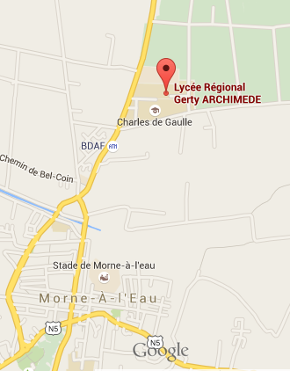
The meeting will take place at LGA
Transportation between accommodation and meeting area will be arranged between participants. The lack of public transport forces us to share rented cars, and perhaps some of our Guadeloupe colleagues can pick up some of us also.

Main issues for the project meeting are:

- Finalising the project outcomes/products
- Ensure that all teams know their tasks and responsibilities
- Quality control and monitoring
- External Quality Report
- Final workshops and target groups
- Final report and Financial report

Please if possible bring laptop computers and also bring an extension cord for multiple sockets if you need to power your laptop

Agenda

N.B. The schedules are only indicative as the agenda should be flexible and other items may be included. Where needed / possible we may also break into groups.

June 28th
Arrival of teams and check in at hotels / apartments

June 29th

08.30 ICT setup, network, beamer etc. (Cecilia Leboeuf)

08.45 Welcome by Mikel Balta and Cecilia Leboeuf

09.00 Walkthrough of achieved results- dissemination and teacher training courses, and a presentation of your plans for the remaining months
- SDE opens the floor
09.05 MCAST presents achievements and plans

LGA presents achievements and plans

MdML presents achievements and plans

ETI presents achievements and plans

SSGT presents achievements and plans

13.00 The final months of the project; planning how to spread our capacities for maximum course participants

13.30 End of working session

June 30th
08.30 Quality Assurance Board: Evaluation of the feedback system that the teams have used for peer-review
- Changes based on evaluations – feedback and response
- How has the feedback been?
- Are teams satisfied with response rates?
- Does the evaluation point at further updates/changes/edits of our material
- Walk through of the External Quality report – points to address

09.45 Dissemination plan;
- Discussion and ideas for further dissemination
- Each team makes a list of final dissemination activities they will take part in: e.g. articles for magazines, newspapers, journals etc., contacting stake-holders, decision makers
- Create a schedule for who will do what and when
- Post list to the dropbox folder

10.30 Presentation of dissemination plan. Each team will present their dissemination plan to the other teams (including dates and responsibilities)

11.00 The project dissemination blog (Web log), evaluation and feedback, how can we make it more visible during the final part of the project?

11.30 Financial report – What is missing? What to do? – Expectations and deadlines for all partners (Mikel and Cecilia)

12.30 Final report - What is missing? What to do? – Expectations and deadlines for all partners (Mikel and Cecilia)

13.30 End of working session

July 1st
Final preparation of conference! All day event.

July 2nd

Conference with teachers and tourist industry

July 3rd

08.00 Sustainability of the project results after the end of the project. Work group discussions and presentation in plenum

08.45 Which measures need to be in place to achieve this?

09.15 Summary of the Project plan, responsibilities, and schedule. We stick to the original work plan dates!

09.45 Meeting evaluation and to do list

10.00 Depature for Cultural Day

July 4th
Departure and travel.

* Please note that meals, drinks etc. due to the EU regulations set out in the financial handbook have to be paid by each participant / national team (the cost is of course covered by the per diem).

