Pre-Assignment Planning e-Record

PAPeR

TOPIC
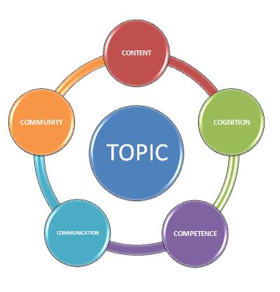

COGNITION
COMPETENCE
COMMUNICATION
COMMUNITY
CONTENT
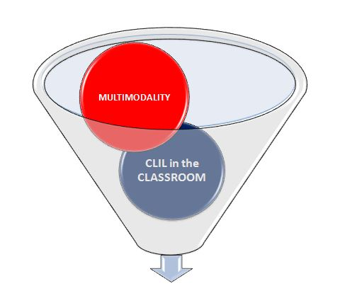

ADD TO PLANNING

MULTIMODALITY
CLIL in the CLASSROOM
- Scaffolding

- Interaction

- Evaluation

