Kick-off Workshop, Brussels 28th-31st October 2013
Meeting Place: EfVET Offices, Rue d'Arlon 40, B-1000, Bruxelles. (Tel +32 2 2343763)
Date and Time: Tuesday, 29/10/13 at 0930
Agenda
NB: This is an indicative running order. However, we may wish to adapt it as we proceed and in response to discussion points as they arise.
1000 - 1100
1. Introductions
A. General - SMO, SDE, Pelikan, Stucom, Ulster, EfVET, (Evaluator?)
B. Exporting partners (SMO, SDE) outline previous POOLS experience and intended shape of POOLS 3.
1115 - 1300
2. Run-through of Work Packages
WP1 (project management) – SMO
WP2 (quality management) – SMO
WP3 (communication platform) - Pelikan
WP4 (exploitation and impact) – SDE
WP5 (dissemination) - EfVET
WP6 (course guide adaptation) - Stucom
WP7 (course book adaptation) – Pelikan
WP8 (creation of audio/video source materials) – SMO (guiding Pelikan, Stucom, Ulster)
WP9 (piloting in-service training) - Ulster
WP10 (DIY instructional videos/DVDs) – SDE
WP11 (Final editing of course guide, course book, sample e-learning units) – SDE

1400 - 1500
3. Consideration of ECORYS Feedback
- Clarify the reason for producing course materials in English
- Consider involving ICT professionals, social partners or learners' representatives in the project, for example through a steering group
- Confirm that lead roles in WP6 and WP7, each related to the adaptation and transfer of existing materials, are attributed to partners with the required skills and understanding
- Develop a dissemination strategy for the 24-month project period ensuring that all partners are involved in the activities
- Translate the project website into all partner languages
- During the first project year, confirm that those policy and decision makers are able to promote wider take-up of the developed materials and approaches in each recipient country, and target these as a part of the project valorisation strategy
- Clearly outline the potential impacts on target groups which might result from the materials being adapted in the selected languages
- Please provide further details for “quality Monitoring/control costs” of 10,000 euro

1515 - 1700

4. Project management and reporting (A)
- Progress reporting
- External evaluation

Wednesday 30/10/13
0930 - 1100
5. Dissemination ideas and platforms
- Website
- Blog/blogs
- Facebook page
- Twitter account
- Linked In account?

1115 – 1300
6. Materials development (A) - Course updates and translations
- Course book
- Course guide

1400 - 1700
7. Materials development (B) – recordings
- View samples (on Clilstore)
- Audio recording with Ipadio – simple introduction
- Create examples (audio or video) – some basic phrases in Catalan, Czech, Irish

Thursday, 31/10/13
0930 - 1300
8. Project management and reporting (B) OR Materials development (B) (continued)
- Financial reporting OR
- Recording production and placement online
The recording production group will meet at the EfVET office. The financial reporting group will meet in an agreed alternative venue.

1400 – 1700
9. Meeting summary and action points, workshop evaluation, IPR agreement, any other business.

House-keeping
N.B. Remember to keep your boarding passes / original travel documents, and receipts.
Please bring a laptop with you. For the “hands-on” introduction to recording please bring whatever audio and/or video recording devices you have, and any appropriate means of uploading content from the recorder to your laptop (for example, to edit). “Recording devices” might be voice recorders, video recorders, mobile phones etc...

Travel Directions and Accommodation options
EfVET have kindly supplied the following information on location and an accommodation option:
Arrival
Brussels Airport is very close to the city – not more than 10-15 minutes by train from the Brussels Airport to Gare du Midid SNCB . Tickets are on sale at the stations. Price:
single fare 7.80€
An alternative way would be to take a taxi from Brussels International Airport to the hotel Thon. The taxi trip costs approximately 30-40€.
Brussels South Charleroi Airport is located at 46 km from Brussels. Directly linked to the city by shuttles (Shuttles Charleroi Airport –Brussels Midi train station).
Shuttles Tariffs: single ticket 14€/ return ticket 28€ tickets also available on the Internet: Brussels South Charleroi Airport. Shuttle Tickets: sold inside the terminal (17 €), counter 1. Trip takes approx. 1 hour.

Local Transport
We recommend using public transportation in Brussels. You can buy tickets from Kiosks, Bootiks (at the metro stops) and some supermarkets. Buying a ticket from the driver (which is only possible in trams and buses) is more expensive. Single tickets allow passengers an unlimited number of changes of metro, tram or bus for 60 minutes (you have to stamp/swipe your card on each new means of transport). Multi-trip cards are not nominative and so can be used between more than one person. We recommend to buy a 10 trip card
10 trip card: 13.50€
For more information on prices, season tickets and discounts: Click here:
http://www.stib.be/tickets.html?l=en

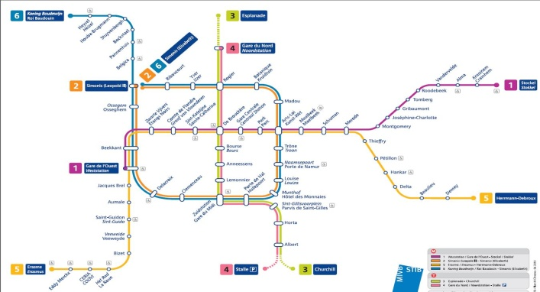

Accommodation

Bristol hotel
THON HOTEL BRISTOL STEPHANIE * * * * - 125 € excluded: breakfast and city tax
Customer number: EfVET or TH22617270
Address: Av.Louise 91-93 (Metro Louise)
B-1050 Brussels
Email address: reservations@thonhotels.be or bebri-hotelplanner@thonhotels.be

THON HOTEL BRISTOL STEPHANIE * * * * - 120 € excluded: breakfast and city tax
Customer number: EfVET or TH22617270
Address: Av.du Boulevard 17 (metro Rogier)
B-1210 Brussels
Email address: reservations@thonhotels.be

Alternative Accommodation

Kent has also researched accommodation options and found this cheaper alternative (though it is already fully booked for the Thursday night, which may not suit those who intend to travel back on the Friday).
ibis Brussels Centre Ste Catherine
Rue Joseph Plateau, 2 Brussels, 1000 Belgien, 43 68 22 98
You can test it through hotels.com
The price is 44.25 EUR per night per room.

